**Module 1 : Spring-Rest-HandOn**

# **Hands on 1: Create a Spring Web Project using Maven**

**Overview and Objectives:**

This hands-on project aims to:

* Demonstrate creation of a Spring Boot application.
* Understand Spring Boot benefits and its simplifications.
* Use XML-based Spring configuration to load beans.
* Incorporate logging into Spring Boot.
* Understand bean scopes – Singleton and Prototype.
* Handle collections in Spring XML configuration.

**Procedure:**

**Step 1: Visit:** [**https://start.spring.io**](https://start.spring.io)

* **Configure:**
  + **Group:** com.cognizant
  + **Artifact:** spring-learn
  + **Dependencies:** Spring Web, Spring Boot DevTools

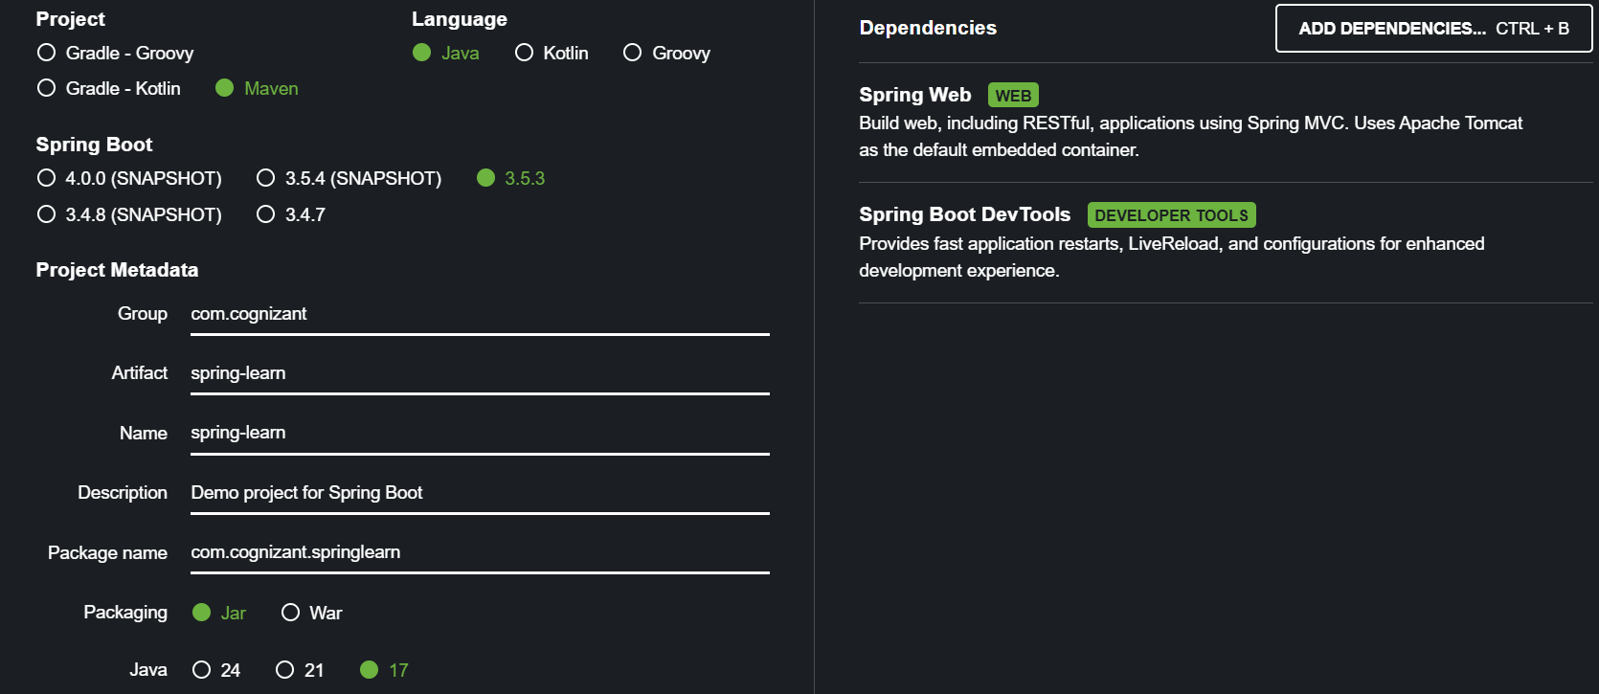

* Download the ZIP and extract to the workspace.

**Step 2: Build the project using the following command:**

* mvn clean package

**Step 3: Import into Eclipse or VS code ( or any editor ) :**

* File > Import > Maven > Existing Maven Projects > Select extracted folder > Finish

**Project Structure Overview:**

* **src/main/java: Source code**
* **src/main/resources: Configuration files**
* **src/test/java: Unit testing code**
* **SpringLearnApplication.java: Main entry class with @SpringBootApplication**

**Explanation:**

* **@SpringBootApplication: Combines @Configuration, @EnableAutoConfiguration, @ComponentScan.**
* **pom.xml: Defines dependencies, plugins, and Maven configs.**

# **Hands on 4: Spring Core – Load Country from Spring Configuration XML**

**Objective:**

**To define a Country bean in a Spring XML configuration and load it in a Spring Boot application using ApplicationContext. This demonstrates the use of:**

* Spring's XML-based configuration
* Property injection via <property>
* Logging for constructors and accessors
* ApplicationContext usage

**Business Use Case:**

**An airline website supports booking for four countries. The home page has a dropdown to select one. Each country has:**

* Two-character ISO code (e.g., IN)
* Full name (e.g., India)
* We'll start by configuring one country (e.g., India) using a Spring XML file.

**Steps to implement:**

**Step 1:** Create **country.xml**

**Create a new XML file named country.xml inside:**

* **src/main/resources** and paste the following:

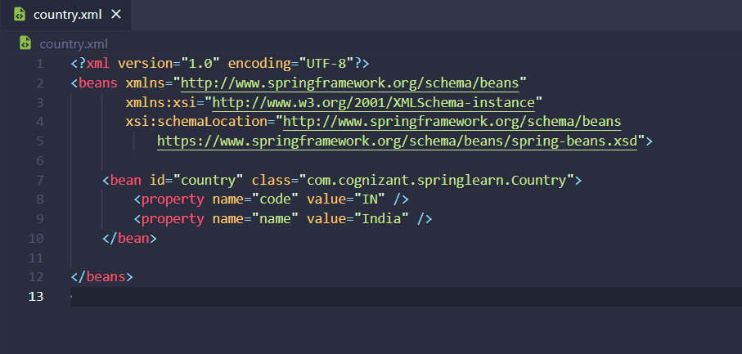

**Step 2:** Create the **Country** Java ClassLocation:

* **src/main/java/com/cognizant/springlearn/Country.java**

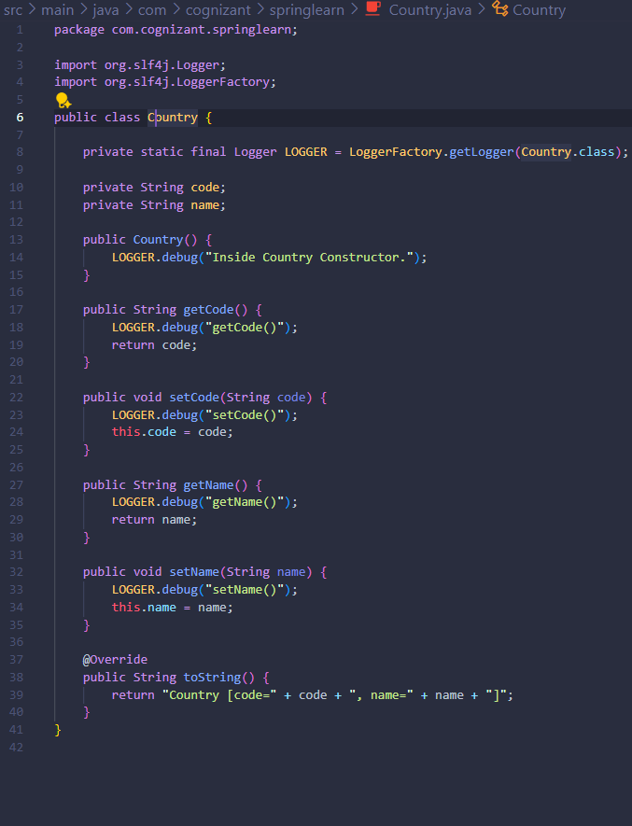

**Step 3:** Add Method **displayCountry()** in **SpringLearnApplication.java**

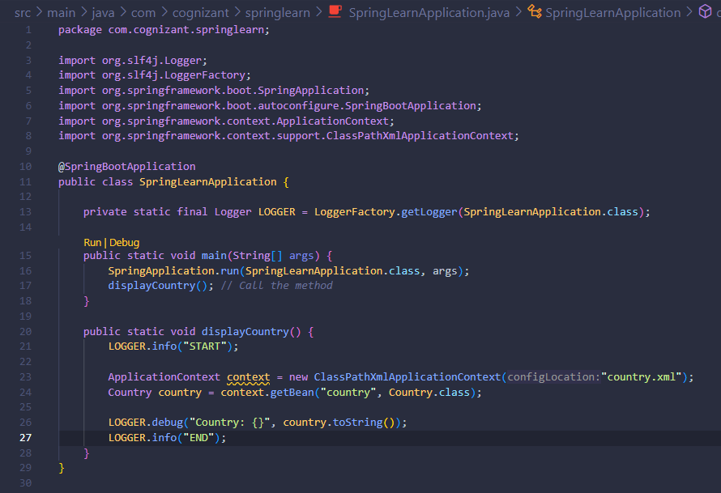

**Step 4:** Run the following code by going into the terminal:

* **mvn spring-boot:run**
* **Expected Output:**

